### **Framework and Libraries**

1. .Net 8
2. Xunit
3. Moq
4. EF Core
5. EF.Core SQ lite
6. AspNetCore.Authentication.JwtBearer
7. Fluent Validation
8. Mapster
9. Bcrypt.Next

### 

### **Authentication**

Username : admin

Password : string

For admin role  
  
On swagger jwt authentication put bearer in front of generated jwt token

ie:  
Bearer jwtToken

### **Database Diagram**

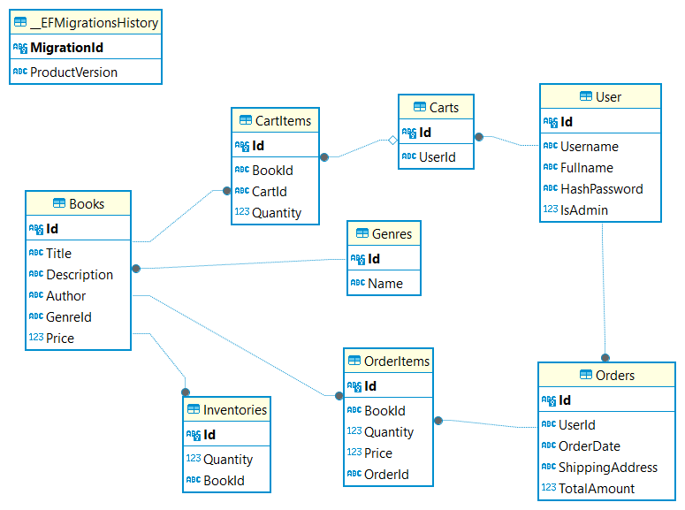

### **Architecture**

Explanation :

1. **Infrastructure :** contain databases, repositories and utils. Not affecting business layer
2. **Presentation :** contain Contract and Api layers. Handle external communication i.e http
   1. **Contract :** contain request dto, response dto and global exception
   2. **Api :** Contain all controllers from the services
3. **Application :** contain all project services, and mapper extension dto. Managing workflows between Domain and external layer
4. **Domain :** contain entities that are used by project. Have no external concern from Api and Database.

### 

### 

### 

### 